SUMMERVILLE CREDIT UNION · CONSOLIDATED MEMBER GUIDE · CSUM-15 of 30
Bill Pay

Module: nFinia Digital Banking > Move Money > Bill Pay
Sources: Summerville Reports Series A (36 docs) + Series B (25 docs) | Features: nFinia Documentation Features Spreadsheet
01 PRODUCT SUMMARY

Bill Pay is an integrated payment service within the nFinia Move Money suite that enables members to pay bills — utilities, insurance, credit cards, subscriptions, and other recurring obligations — directly from their Summerville account without leaving the digital banking platform. Members can pay one-time bills on demand or set up recurring scheduled payments to ensure obligations are met on time every month.
The Bill Pay service is delivered through an integrated third-party provider that maintains a comprehensive payee database covering thousands of national and local billers. Members can add payees manually or search the database. Electronic payments to e-pay-enabled billers arrive in 1–2 business days; check payments to non-electronic billers are mailed within 3–5 business days.
The Bill Pay module includes full history of all past payments, management of payee details (nickname, account number, delivery preference), and the ability to view pending payments and upcoming scheduled payments in one place.

At a Glance

Attribute | Detail
Module | Move Money > Bill Pay
Biller Types | Electronic (1–2 days) and check (3–5 days)
Schedules | One-time, recurring (weekly, bi-weekly, monthly)
Payee Management | Add, edit, delete payees; view/edit payment details
History | Full payment history with biller name, amount, and date
Related Reports | CSUM-06 (Move Money Hub), CSUM-13 (Wire Transfers)

02 KEY USE CASES

Use Case | Who Uses It | What They Do | Business Value
Pay Utility Bill | Members paying monthly utilities | Add utility as payee, enter amount, select pay date, submit | Single-platform bill payment without visiting each biller's site
Set Up Recurring Payment | Members automating monthly bills | Create a recurring payment schedule for a payee | Automation ensures bills never miss due dates
Add New Payee | Members adding a new biller | Search payee database or manually enter biller details | Builds personalised payee list for all regular obligations
Review Payment History | Members reconciling payments | Open Bill Pay > History to view all past payments | Complete audit trail of all bill payments made through the platform

03 STEP-BY-STEP GUIDE

Navigation: Dashboard > Move Money > 'Bill Pay'.

Step 1 — Start from Dashboard
The member begins at the Dashboard after logging in. The Dashboard displays all account balances, upcoming payments, quick-action tiles, and the top navigation bar with links to Accounts, Move Money, and More.
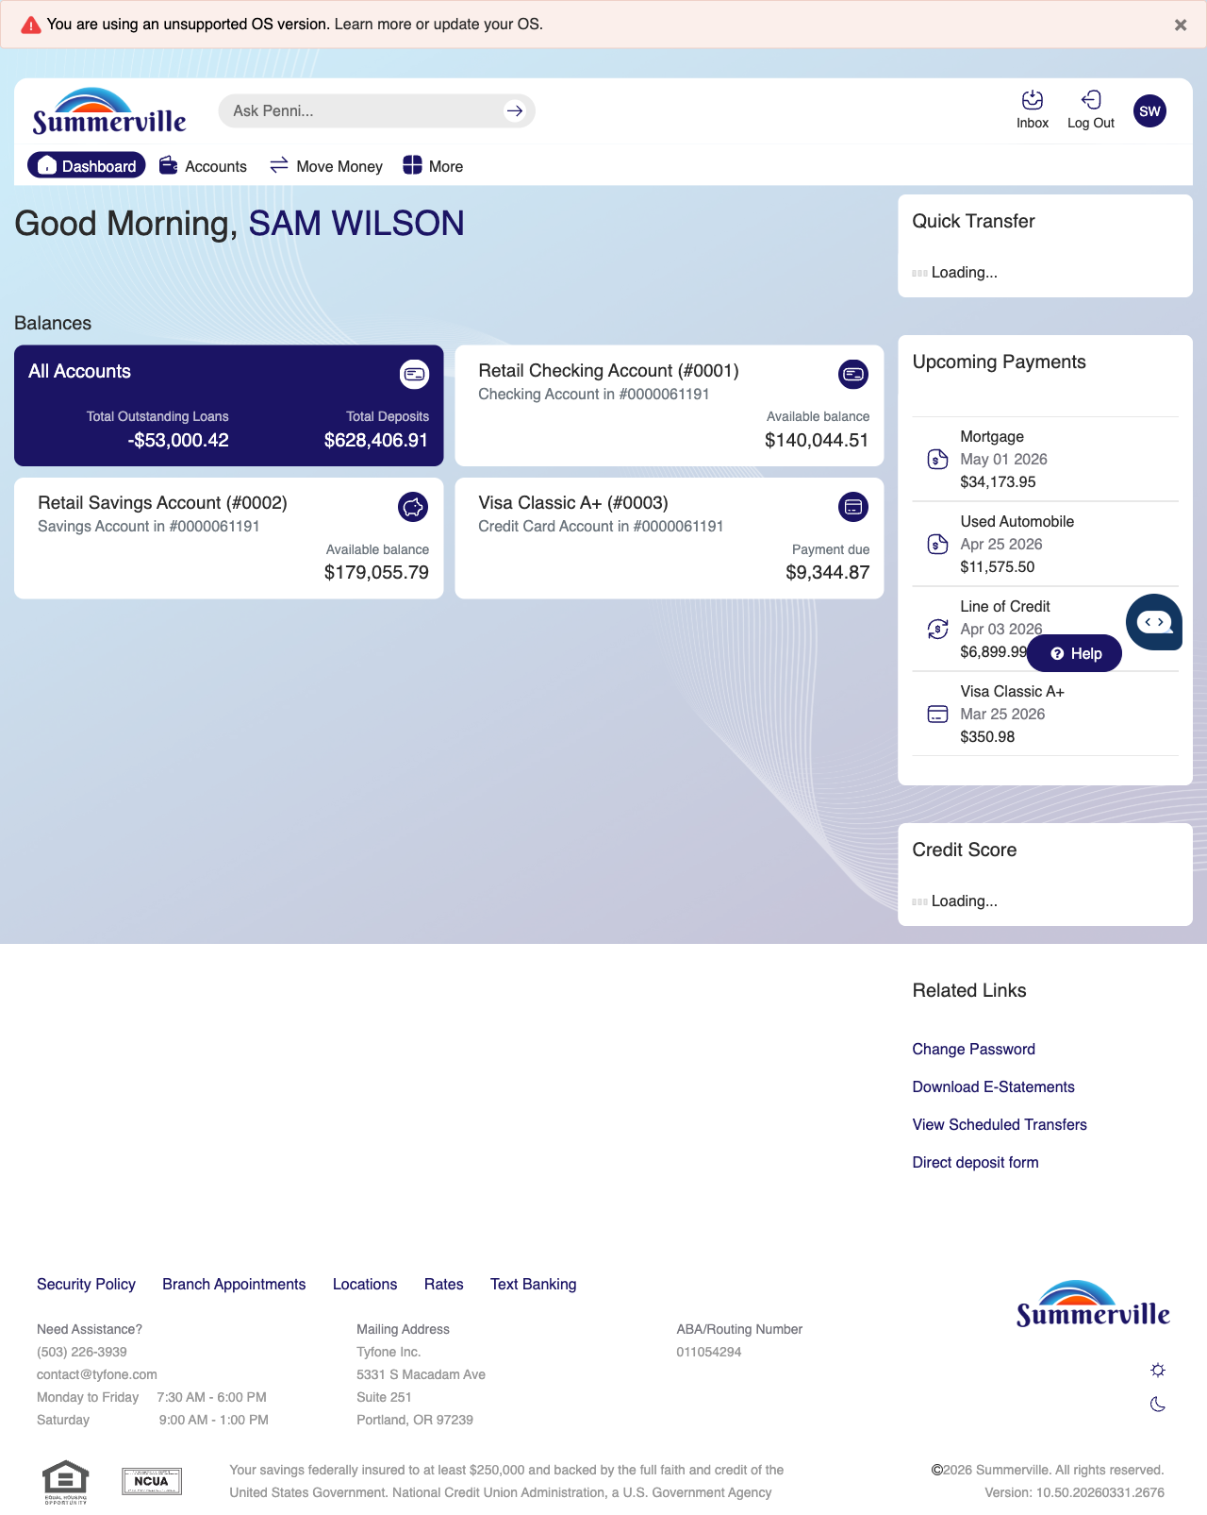
Step 1: Start from Dashboard

Step 2 — Navigate to Move Money Hub
The member clicks ‘Move Money’ in the top navigation bar. The Move Money Hub displays all payment and transfer options as tiles including Pay Bills, Quick Pay, Zelle Payment, Internal Transfers, Other Members, Same-Day Transfers, Send Instantly, Manage Recipients, Add Recipient, Transaction History, Scheduled Transfers, and P2P Transfer.
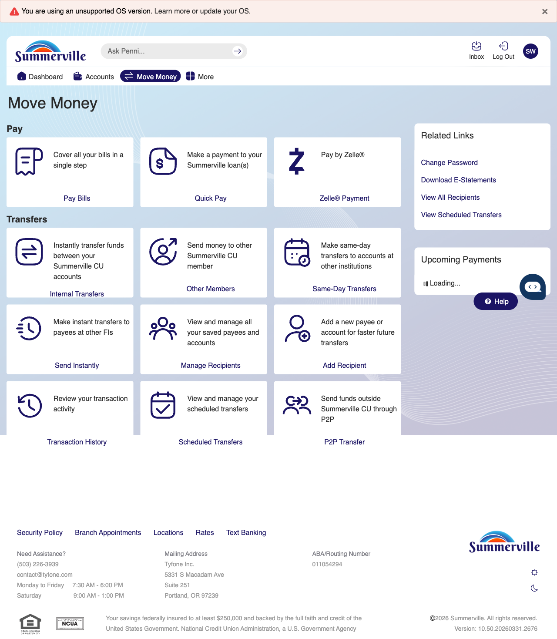
Step 2: Move Money Hub

Step 3 — Navigate from Dashboard to Bill Pay
The Bill Pay screen from the legacy banking interface is displayed, showing payment options and form fields for setting up or making a bill payment.
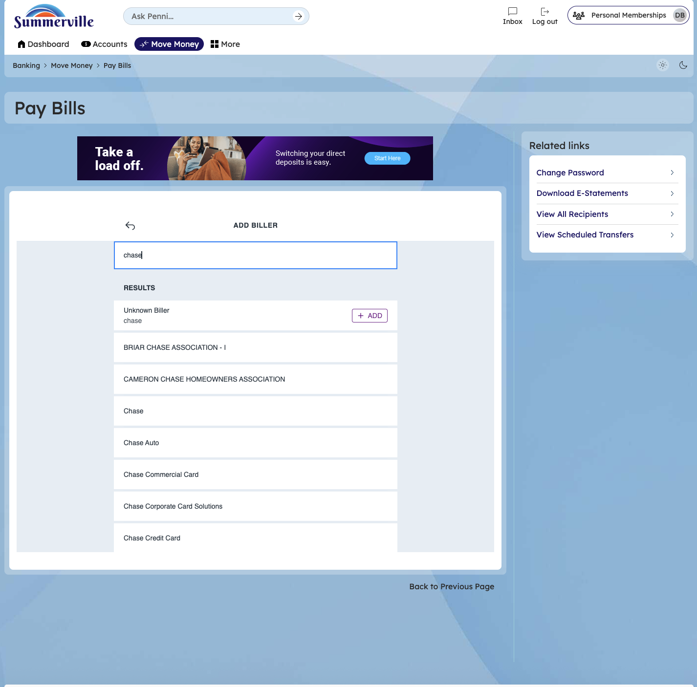

Step 4 — ADD BILLER
Enter the Biller details and add Biller